INSTALL RESPIN – Debian
INSTALL RESPIN ON DEBIAN 9.6

Debian 9.6
git

STEP 1
PACKAGES

Required Packages:

Dependencies are installed during respin installation.
Download respin or use git to clone the latest respin.

Sourceforge: https://sourceforge.net/projects/respin/files/
Gitlab: https://gitlab.com/remastersys/LinuxRespin

Note: mkisofs deprecated – uses genisoimage instead

STEP 2
INSTALL PACKAGES

Install dependencies/packages needed for respin (as root).
- Install git
- Install respin

apt-get -y install git
git clone https://gitlab.com/remastersys/LinuxRespin
dpkg -i 4.0.0-2_all.deb

STEP 3
RUN RESPIN

There are several options for backup and iso creation.
To use any option, run respin as root. There is a 4.2 gb limit at this time.

To make a live CD/DVD backup

respin backup

To make a live CD/DVD backup iso called “custom.iso”

respin backup custom.iso

To create a live CD/DVD of your system

respin dist

To create a live CD/DVD of your system – filesystem only

respin dist cdfs

To make a distributable iso (mynew.iso), but only if cdfs exists

respin dist iso mynewiso.iso

Before running respin clean move your files to another location. To clean the files from the build.

respin clean

UNINSTALL RESPIN
REMOVE RESPIN

In the event you wish to remove respin, as superuser, use:

apt-get remove respin
or
apt-get purge respin

… to be continued
RESPIN USB WRITER
0.0.0-1

APPENDIX A
installation images

Figure A-1. respin options

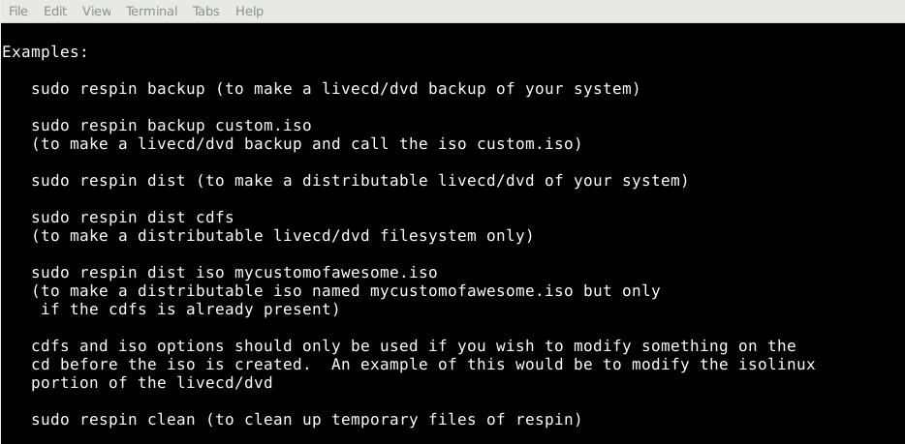

Figure A-2. respin clean - before

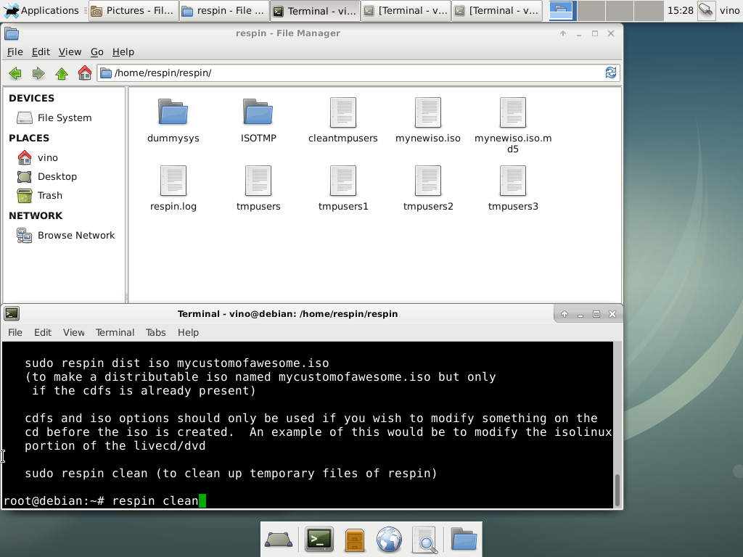

Figure A-3. respin clean – after

